Internet Technologies

PRACTICAL FILE

**AKANKSHA GOEL**

**0726**

***PRACTICAL***

***1.Display your systems IP Address, Subnet mask using ipconfig, and find out the network address and the maximum number of systems possible on your network and range of IP addresses available to these systems.***

**C:\Users>ipconfig**

Windows IP Configuration

Ethernet adapter Ethernet:

Media State . . . . . . . . . . . : Media disconnected

Connection-specific DNS Suffix . :

Wireless LAN adapter Local Area Connection* 1:

Media State . . . . . . . . . . . : Media disconnected

Connection-specific DNS Suffix . :

Wireless LAN adapter Local Area Connection* 2:

Media State . . . . . . . . . . . : Media disconnected

Connection-specific DNS Suffix . :

Wireless LAN adapter Wi-Fi:

Connection-specific DNS Suffix . :

Link-local IPv6 Address . . . . . : fe80::5828:36b4:f031:fa6c%4

**IPv4 Address. . . . . . . . . . . : 192.168.1.12**

**Subnet Mask . . . . . . . . . . . : 255.255.255.0**

Default Gateway . . . . . . . . . : fe80::76da:daff:fecc:bb3a%4

192.168.1.1

Ethernet adapter Bluetooth Network Connection:

Media State . . . . . . . . . . . : Media disconnected

Connection-specific DNS Suffix . :

**IPv4 Address . . . . . . . . . . . : 192 . 168 . 1 . 12**

**Subnet Mask . . . . . . . . . . . : 255 . 255 . 255 . 0**

**--------------------------------------------**

**Subnet number 192 . 168 . 1 . 0**

**--------------------------------------------**

**First Ip Address 192 . 168 . 1 . 1**

**Last Ip Address 192 . 168 . 1 . 254**

**Broadcast Ip Address 192 . 168 . 1 . 255**

No Of Systems Possible Are : 254

***2.With help of ping, check if you are connected to other systems of your network and find the route to connect to that system using tracert. List all the processes which are using ports for TCP protocol.***

**PING MY MOBILE NUMBER**

**IP ADDRESS -**192.168.1.5

**C:\Users>Ping 192.168.1.5**

Pinging 192.168.1.5 with 32 bytes of data:

Reply from 192.168.1.5: bytes=32 time=12ms TTL=64

Reply from 192.168.1.5: bytes=32 time=127ms TTL=64

Reply from 192.168.1.5: bytes=32 time=127ms TTL=64

Reply from 192.168.1.5: bytes=32 time=229ms TTL=64

Ping statistics for 192.168.1.5:

Packets: Sent = 4, Received = 4, Lost = 0 (0% loss),

Approximate round trip times in milli-seconds:

Minimum = 12ms, Maximum = 229ms, Average = 123ms

TRACE ROUTE 192.168.1.5

C:\Users\ap123>tracert 192.168.1.5

Tracing route to 192.168.1.5 over a maximum of 30 hops

1 4 ms 8 ms 4 ms 192.168.1.5

Trace complete.

**PING REMAINING ADDRESSES**

**C:\Users>Ping 192.168.1.3**

Pinging 192.168.1.3 with 32 bytes of data:

Reply from 192.168.1.3: bytes=32 time=19ms TTL=64

Reply from 192.168.1.3: bytes=32 time=7ms TTL=64

Reply from 192.168.1.3: bytes=32 time=5ms TTL=64

Reply from 192.168.1.3: bytes=32 time=15ms TTL=64

Ping statistics for 192.168.1.3:

Packets: Sent = 4, Received = 4, Lost = 0 (0% loss),

Approximate round trip times in milli-seconds:

Minimum = 5ms, Maximum = 19ms, Average = 11ms

**C:\Users>Ping 192.168.1.10**

Pinging 192.168.1.10 with 32 bytes of data:

Reply from 192.168.1.10: bytes=32 time=1065ms TTL=64

Reply from 192.168.1.10: bytes=32 time=28ms TTL=64

Reply from 192.168.1.10: bytes=32 time=116ms TTL=64

Reply from 192.168.1.10: bytes=32 time=111ms TTL=64

Ping statistics for 192.168.1.10:

Packets: Sent = 4, Received = 4, Lost = 0 (0% loss),

Approximate round trip times in milli-seconds:

Minimum = 28ms, Maximum = 1065ms, Average = 330ms

C:\Users\ap123>tracert 192.168.1.10

Tracing route to 192.168.1.10 over a maximum of 30 hops

1 DESKTOP-VFJ6PDB [192.168.1.12] reports: Destination host unreachable.

Trace complete.

**NETSTAT**

Command – netstat

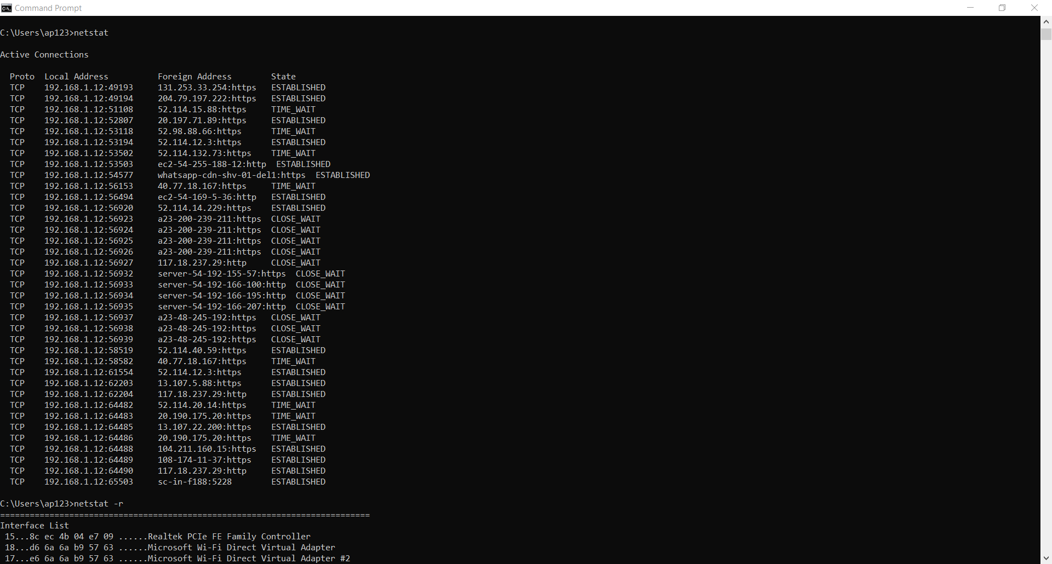

*Command – netstat -r*

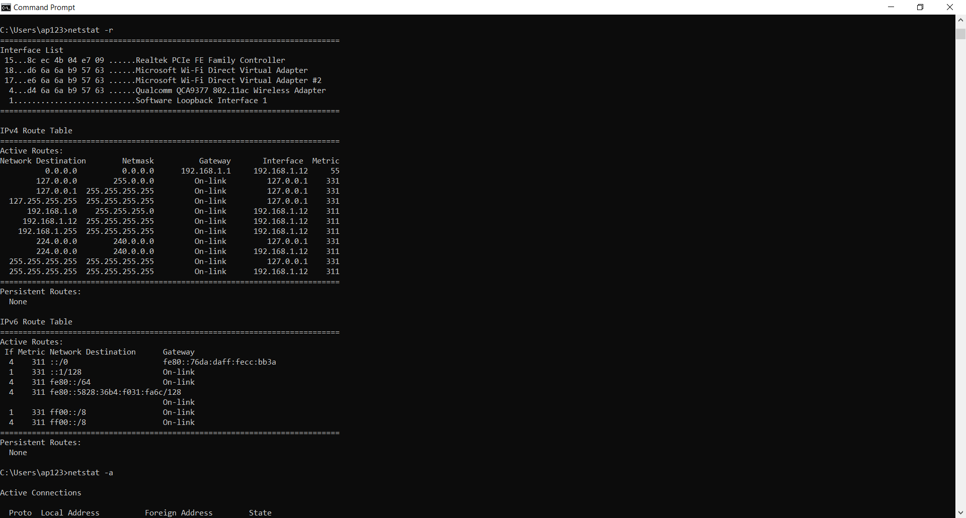

*Command – netstat-a*

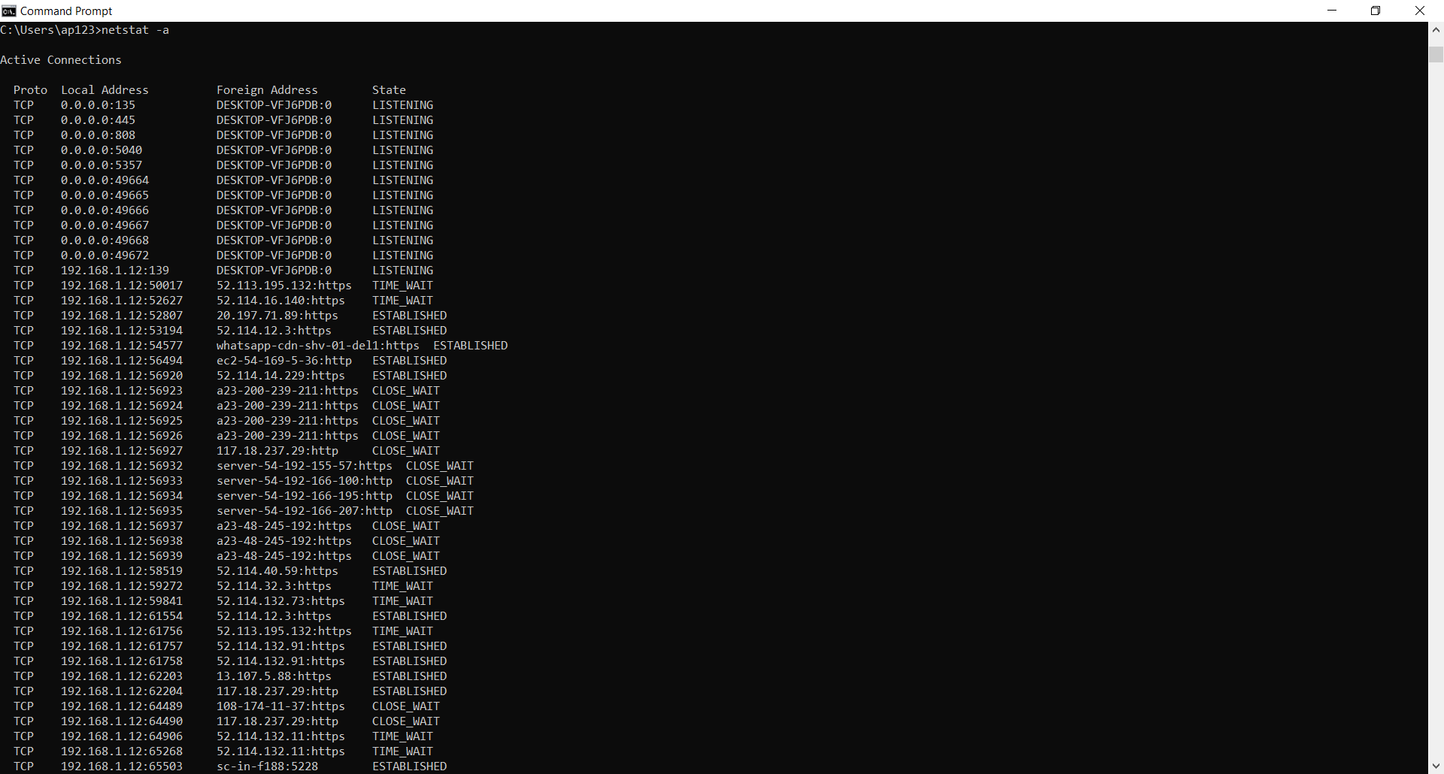

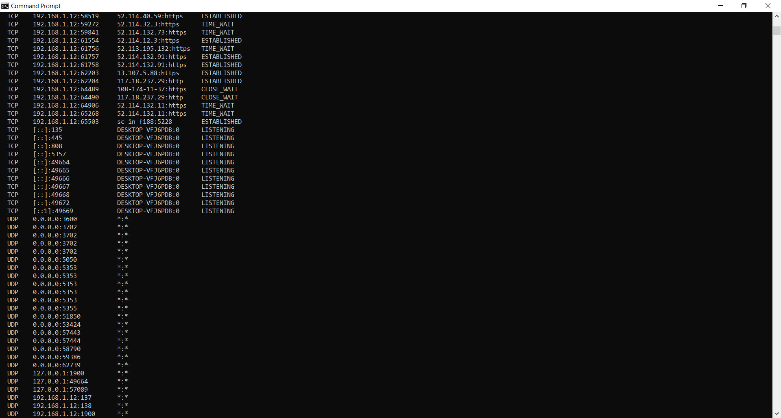

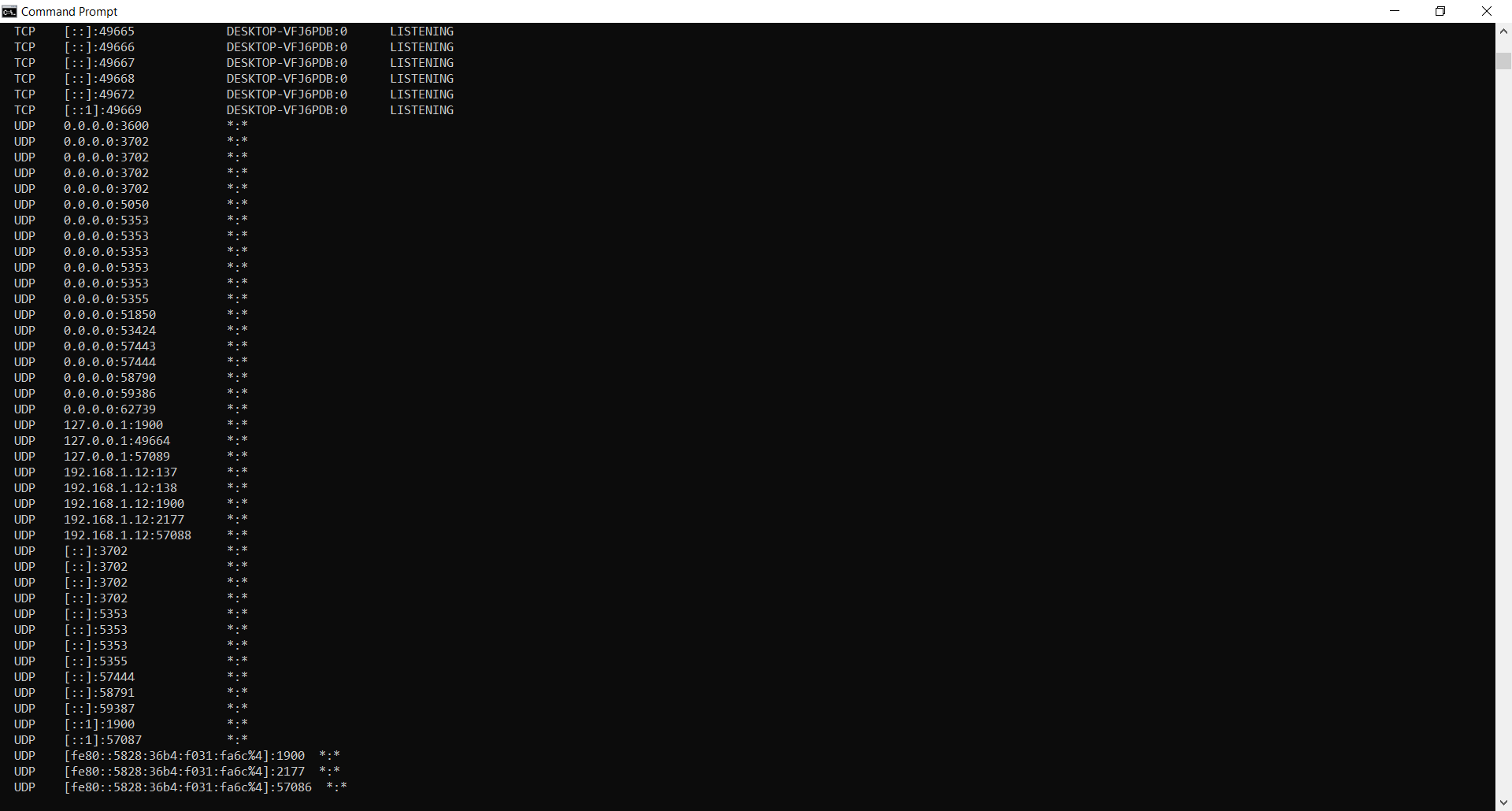

***3.Create an HTML page that shows information about you, your course, hobbies, address, and your plans. Use CSS for styling of HTML page so that looks nice.***

<!DOCTYPE html>

<html>

<head>

<title>IT PRACTICAL-3</title>

</head>

<style>

marquee{ color:Red;

background-color:white;

width:400px;

text-align:center;

font-size:30px;}

h3{background-color:light-yellow;

color:black;

text-align:center-right;

width:500px;}

body{background-color:black;}

#a{

display: grid;

width:400px;

background-color:pink;

padding-top:50px;

}

img{

padding-left:100px;}

</style>

<div id="a">

<body>

<marquee>PERSONAL DETAILS</marquee><br><br><br>

<img src="me.jpg" width="200px" height="250px"></img>

<h3>NAME : Akanksha goel</h3>

<h3>COURSE : BSC(Hons.)Computer Science</h3>

<h3>ADDRESS : 25/133 Shakti nagar , delhi - 110007</h3>

<h3>HOBBIES : Playing</h3>

<h3>FUTURE PLANS : Noy yet planned</h3>

</div>

</body>

</html>

***OUTPUT***

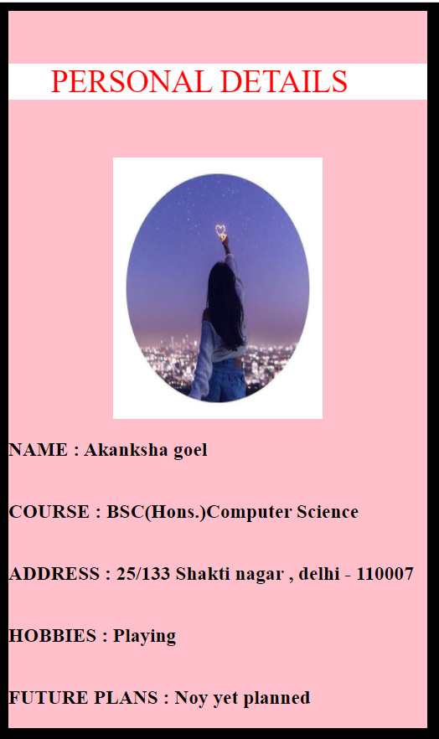

***4.Create an HTML page with the sole purpose to show multiplication tables of 2 to 10 (row-wise) created by JavaScript. Initially, the page is blank. With help of setInterval function print a row every 5 seconds in different colors and increasing font size.***

<!DOCTYPE html>

<html>

<head>

<title>IT PRACTICAL-4</title>

<style type="text/css">

table{

border: 2px solid black;

border-collapse: collapse;

width: 90%;

margin: auto;

}

td,th{

border: 2px solid black;

padding: 5px;

}

#t1{

text-align: center;

background-color:white;

}

body{

background-color:#FFFFB7;

}

h1{

text-align: center;

text-decoration:underline;

}

</style>

</head>

<body>

<h1>TABLES</h1>

<table id="t1"></table>

<script type="text/javascript">

function getRandomColor() {

var letters = '0123456789ABCDEF';

var color = '#';

for (var i = 0; i <6; i++) {

color += letters[Math.floor(Math.random()*16)];

}

return color;

}

var table = document.getElementById('t1');

var number = 2;

var interval = setInterval(print_tables,5000);

function print_tables(){

if (number == 10)

{

clearInterval(interval);

}

var result = "";

for(var i = 1; i<= 10; i++){

result = result + "<td>"+ number + "*" + i + "=" + number * i+"</td>";

}

number++;

var row = document.createElement('tr');

row.style.color= getRandomColor();

row.style.fontSize = (number+12)+"px";

row.innerHTML=result;

table.append(row);

}

</script>

</body>

</html>

***OUTPUT***

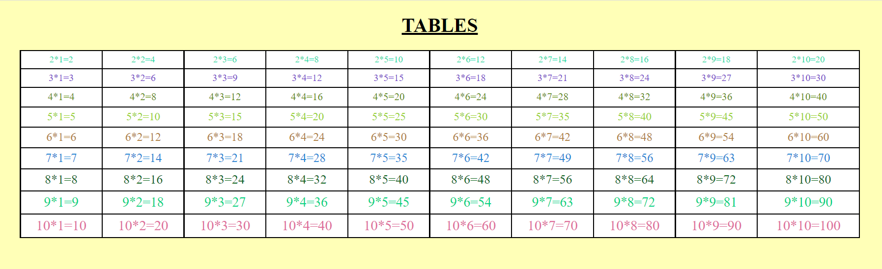

***5.Create an HTML page with a paragraph written on it and under which 9 buttons are placed in a 3X3 grid. The first row is for buttons labeled with colors names Red, Green, and Blue, the second row with numbers 10, 20, 30, and the third row with different font names. Click event of each of the buttons should make the appropriate change in the style of paragraph.***

<!DOCTYPE html>

<html>

<head>

<title>IT PRACTICAL-5</title>

<style type="text/css">

.btn-box{

display: flex;

flex-wrap: wrap;

justify-content: space-around;

padding: 10px;

}

.color, .fontSize, .fontStyle{

width: 300px;

height: 35px;

margin-bottom: 10px;

font-weight: bold;

font-size: 15px;

}

h1{

text-align:center;

color:black;

text-decoration:underline;

}

body{background-color:#B5FDFD;

}

.color{

color: #FBFCFE;

background-color: #9885EB ;

}

.fontSize{

color: #FBFCFE;

background-color:#7458EE ;

}

.fontStyle{

color: #FBFCFE;

background-color: #4A23F3 ;

}

p{

background-color:#EBF5FB ;

}

</style>

</head>

<body>

<h1>STYLE MENU</h1>

<p id="para">

Lorem Ipsum is simply dummy text of the printing and typesetting industry.

Lorem Ipsum has been the industry's standard dummy text ever since the 1500s,

when an unknown printer took a galley of type and scrambled it to make a type specimen book.

It has survived not only five centuries, but also the leap into electronic typesetting,

remaining essentially unchanged. It was popularised in the 1960s with the release of Letraset sheets

containing Lorem Ipsum passages, and more recently with desktop publishing software like Aldus PageMaker

including versions of Lorem Ipsum.

Why do we use it?

It is a long established fact that a reader will be distracted by the readable content of a page

when looking at its layout. The point of using Lorem Ipsum is that it has a more-or-less normal

distribution of letters, as opposed to using 'Content here, content here', making it look like readable English.

Many desktop publishing packages and web page editors now use Lorem Ipsum as their default model text,

and a search for 'lorem ipsum' will uncover many web sites still in their infancy. Various versions have evolved over the years,

sometimes by accident, sometimes on purpose (injected humour and the like).

Where does it come from?

Contrary to popular belief, Lorem Ipsum is not simply random text. It has roots in a piece of classical Latin literature from 45 BC

, making it over 2000 years old. Richard McClintock, a Latin professor at Hampden-Sydney College in Virginia, looked up one of the

more obscure Latin words, consectetur, from a Lorem Ipsum passage, and going through the cites of the word in classical literature,

discovered the undoubtable source. Lorem Ipsum comes from sections 1.10.32 and 1.10.33 of "de Finibus Bonorum et Malorum"

(The Extremes of Good and Evil) by Cicero, written in 45 BC. This book is a treatise on the theory of ethics, very popular during the Renaissance.

The first line of Lorem Ipsum, "Lorem ipsum dolor sit amet..", comes from a line in section 1.10.32.

The standard chunk of Lorem Ipsum used since the 1500s is reproduced below for those interested. Sections 1.10.32 and

1.10.33 from "de Finibus Bonorum et Malorum" by Cicero are also reproduced in their exact original form, accompanied by

English versions from the 1914 translation by H. Rackham.

</p>

<div class="btn-box">

<button class="color">Red</button>

<button class="color">Lime</button>

<button class="color">Fuchsia</button>

</div>

<div class="btn-box">

<button class="fontSize">10</button>

<button class="fontSize">20</button>

<button class="fontSize">30</button>

</div>

<div class="btn-box">

<button class="fontStyle">'Brush Script MT', cursive</button>

<button class="fontStyle">'Courier New', monospace</button>

<button class="fontStyle">'Jokerman' , bold</button>

</div>

<script type="text/javascript">

var colors = document.getElementsByClassName("color");

var fontSizes = document.getElementsByClassName("fontSize");

var fontStyles = document.getElementsByClassName("fontStyle");

var element = document.getElementById('para');

for (var i = 0; i < colors.length; i++) {

colors[i].addEventListener('click', changeColor);

}

for (var i = 0; i < fontSizes.length; i++) {

fontSizes[i].addEventListener('click', changeFontSize);

}

for (var i = 0; i < fontStyles.length; i++) {

fontStyles[i].addEventListener('click', changeFontStyle);

}

function changeColor(){

element.style.color = this.innerHTML;

}

function changeFontSize(){

element.style.fontSize = this.innerHTML+'px';

}

function changeFontStyle(){

element.style.fontFamily = this.innerHTML;

}

</script>

</body>

</html>

***OUTPUT***

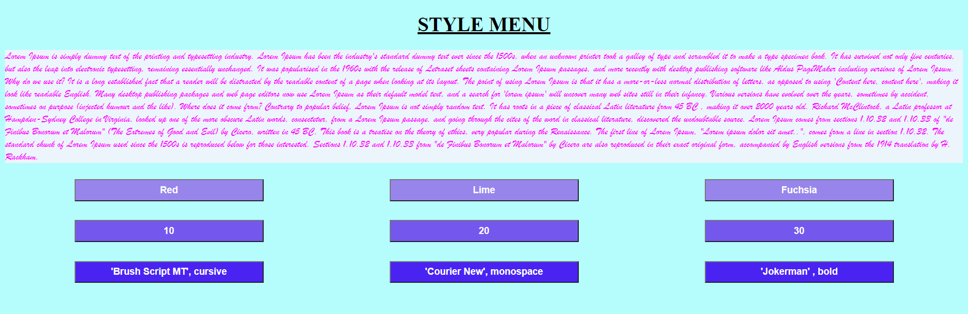

***6.Create a form that takes data about a pet. The form must be well designed and should accept the pet’s name,age,type, and what it likes most. At the submission of this form create a Pet object in JavaScript filled with these values and log that object and equivalent JSON on the console.***

<!DOCTYPE html>

<html>

<head>

<title>IT PRACTICAL-6</title>

<style type="text/css">

body{

background-color:#FFFFB7;

}

h1{

text-align: center;

text-decoration:underline;

}

input{

text-align: center;

padding:5px 40px ;

}

#submit{

text-align: center;

}

</style>

</head>

<body>z

<fieldset>

<h1 align="center" >PET'S FORM</h1>

<table>

<tr>

<td><label for=" name"> NAME</label></td>

<td><input type="text" id="name" name="name" ></td>

</tr>

<tr>

<td><label for="age">AGE</label></td>

<td><input type="number" id="age" name="age" min="0"></td>

</tr>

<tr>

<td><label for=" wgt">WEIGHT(in kgs)</label></td>

<td><input type="number" id="wgt" name="wgt" min="0"></td>

</tr>

<tr>

<td><label for="ty" >TYPE</label></td>

<td><input type="text" id="ty" name="ty"></td>

<td></td>

</tr>

<tr>

<td><label for="thing">LIKELY THING</label></td>

<td><input type="text" id="thing" name="thing"></td>

<td></td>

<td></td>

</tr>

<tr>

<td>

<button type="submit" onclick="abc()" id="submit">SUBMIT</button>

</td>

</tr>

</table>

</fieldset>

<script type="text/javascript">

function abc(){

event.preventDefault();

var array={};

var name = document.getElementById("name");

var age= document.getElementById("age");

var weight=document.getElementById("wgt");

var t=document.getElementById("ty");

var thing=document.getElementById("thing");

array={"name":name.value,"age":age.value,"weight":weight.value,"type":t.value,"thing":thing.value};

console.log(JSON.stringify(array));

console.log(array);

}

</script>

</body>

</html>

***OUTPUT***

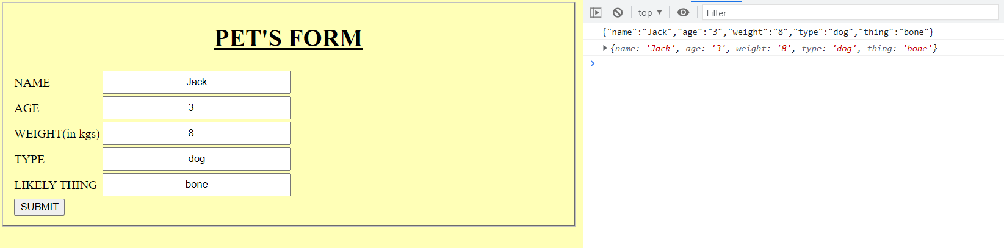

***7.Store JSON data of few pets that you created in previous practical in a JSON file (copy from console output of previous program to a .json file). Using AJAX, load data from the file and display it in a presentable way using HTML and CSS***

<!DOCTYPE html>

<html>

<head>

<title>PRACTICAL -7</title>

<style type="text/css">

button{

background-color: black;

color: white;

padding: 8px ;

text-align: center;

}

</style>

</head>

<body>

<div id="1"></div>

<button id="btn1">CLICK</button>

<script

src="https://code.jquery.com/jquery-3.6.0.js"></script>

<script>

var txt=document.getElementById("1");

document.getElementById("btn1").addEventListener('click',display);

function display()

{

var ourRequest=new XMLHttpRequest();

ourRequest.open('GET','pets.json',true);

ourRequest.onload=function()

{

var data=JSON.parse(ourRequest.responseText);

renderHTML(data);

};

ourRequest.send();

}

function renderHTML(data){

for (var i = 0; i <data.length; i++){

txt.innerHTML+="<p>"+ data[i].name + " is a " + data[i].type +" whose age is "+ data[i].age + " and weight is " +data[i].weight

+ " kg likes to eat. " + data[i].thing ;

//string += '.</p>';

}

}

</script>

</body>

</html>

**PET.JSON**

[

{"name": "Jack", "age": "1", "weight": "3", "type": "dog", "thing": "bone"},

{ "name": "Jaguar", "age": "3", "weight": "10", "type": "cat", "thing": "flesh"},

{"name": "Mac", "age": "6", "weight": "0.8", "type": "bird", "thing": "chillies"},

{"name":"Tom","age":"2","weight":"5","type":"cat","thing":"biscuit"}

]

***OUTPUT***

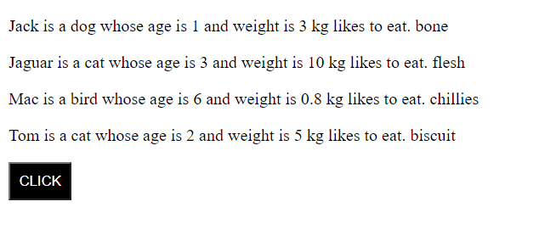

***8.Create a plain HTML page for B.Sc. Hons CS course, mentioning details like fee, eligibility criteria, papers with names and credits, and future possibilities after the course. A button for styling should be there at bottom of the page. On clicking on this button JavaScript should redesign the complete page using jQuery in a nice presentable way.***

<!DOCTYPE html>

<html>

<head>

<title> IT PRACTICAL -8</title>

</head>

<body>

<h1>BSc Honors Computer Science</h1>

<table id="tab">

<tr>

<th>ABOUT COURSE</th>

<td>

<p id="intro">

The Department of Computer Science offers 3-year B.Sc. (Hons.) Computer Science programme through constituent colleges of the University of Delhi. With the new advancements in the field of computers and in a time when there is a boom in the IT industry, the University of Delhi has introduced B.Sc (Hons.) Computer Science, a 3-year undergraduate programme, for the tech-savvy youth. The colleges are contributing to the development of Information Technology by offering this programme with the help of efficient and highly qualified teachers and through well-equipped computer labs. The programme provides rigorous foundations of the concepts of Computer Science and Information Technology. In the final year, students also get an opportunity to do project work. Hence the combination of the concepts and training of software tools equip the students to adapt to ever-changing technology. The B.Sc. (Hons.) Computer Science programme primarily intends to serve as an input for higher degree academic programmes in Computer Science . The programme lays emphasis on building a strong mathematical foundation (about 30% of course work) and includes modules on electronics and humanities as well.

</p>

</td>>

</tr>

<tr>

<th>FEES</th>

<td>The B. Sc in computer science fees range in between INR 1 lakhs to INR 7 lakhs.</td>

</tr>

<tr>

<th>ELIGIBILITY</th>

<td><ul>

To be eligible to enrol in for the B. Sc. in computer science degree courses you need to clear the following eligibility criteria:

<li>Students need to have graduated their 12th standard in the science stream with physics, chemistry and mathematics (PCM).</li>

<li>Some private colleges may grant admission to students who have science with physics, chemistry and biology (PCB).</li>

<li>Some even grant admission to students from different streams.</li>

</ul></td>

</tr>

<tr>

<th>SYLLABUS</th>

<td>

<ul>

<h3>Core Subjects</h3>

<li>Java</li>

<li>C++</li>

<li>Discrete Structures</li>

<li>Computer Science Architecture</li>

<li>Android</li>

<li>Web Development</li>

<li>Python</li>

<li>Microprocessor</li>

<li>Internet Technology</li>

<li>Computer Network</li>

<li>Software Engineering</li>

<li>DataBase Management System</li>

<li>Data Analysis and Visualisation</li>

</ul>

<ul>

<h3>Electives</h3>

<li>Domain Specific Elective(DSE)</li>

<li>Generic Elective(GE)</li>

<li>Ability Enhacement Elective(AEEC)</li>

</ul>

</td>

</tr>

<tr>

<th>SCOPE</th>

<td><p id="scope">The B. Sc. in computer science has immense scope in India. Computer education has always had a lot of importance owing to the country’s IT industry. Therefore, a B. Sc in computer science degree has a lot of value and will most likely lead to employment with a good salary and benefits. Computer education in India is so important that people who do other degrees also do additional computer-based certification courses to add value to their degree.</p></td>

</tr>

<tr>

<th>CAREER JOB OPPURTUNITIES</th>

<td>To know about the B. Sc in computer science, you also have to know what careers become eligible for you with the degree. Here are the career and job opportunities after B. Sc in computer science:

<ul>

<li>Software Engineer</li>

<li>Software Developer</li>

<li>Application Developer</li>

<li>It Support</li>

<li>Network System Developer</li>

</ul>

</td>

</tr>

</table>

<button align="center">PRESS TO STYLE</button>

<script src="https://code.jquery.com/jquery-3.6.0.js"></script>

<script type="text/javascript">

$(document).ready(function(){

$("button").click(function(){

$("body").css({"background-color":"white"});

$("#tab").css({"background-color":"#5480F7","width":"80%","border" :"2 px solid black","margin":"auto","padding":"5px"});

$("tr,td").css({"margin":"6px","padding":"5px","background-color":"#E6EBF9"});

$("h1").css({"text-align":"center","color":"#061848","background-color":"whites"});

$("th").css({"font-family":"Courier New","font-size":"3s0px"});

$("li").css({"font-family":"Times New Romans","color":"#061848"});

});

});

</script>

</body>

</html>

***OUTPUT***

***BEFORE STYLING***

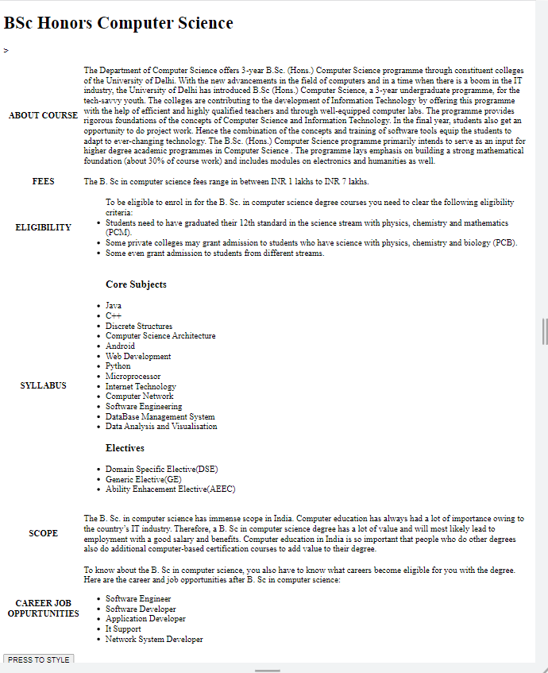

***AFTER STYLING***

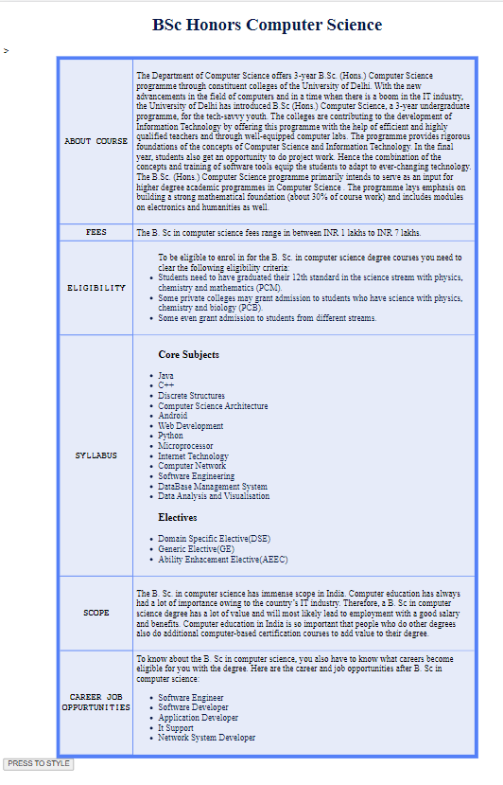

***9.Create an HTML page for an image gallery which shows the use of BOOTSTRAP to rearrange and resize its contents on resizing the browser.***

<!DOCTYPE html>

<html lang="en">

<head>

<title>PRACTICAL-9</title>

<meta charset="utf-8">

<meta name="viewport" content="width=device-width, initial-scale=1">

<link rel="stylesheet" href="https://maxcdn.bootstrapcdn.com/bootstrap/3.4.1/css/bootstrap.min.css">

<style type="text/css">

img{

height:350px;

width:350px;

padding: 5px ;

}

</style>

</head>

<body>

<h1 align="center">Responsive image gallery</h1>

<div class="container">

<img class="col-sm-4" src="abc.jpeg"></img>

<img class="col-sm-4" src="abc.jpeg"></img>

<img class="col-sm-4" src="abc.jpeg"></img>

<img class="col-sm-4" src="abc.jpeg"></img>

<img class="col-sm-4" src="abc.jpeg"></img>

<img class="col-sm-4" src="abc.jpeg"></img>

<img class="col-sm-4" src="abc.jpeg"></img>

<img class="col-sm-4" src="abc.jpeg"></img>

<img class="col-sm-4" src="abc.jpeg"></img>

</div>

<div>

<script src="https://ajax.googleapis.com/ajax/libs/jquery/3.5.1/jquery.min.js"></script>

<script src="https://maxcdn.bootstrapcdn.com/bootstrap/3.4.1/js/bootstrap.min.js"></script>

</div>

</body>

</html>

***OUTPUT***

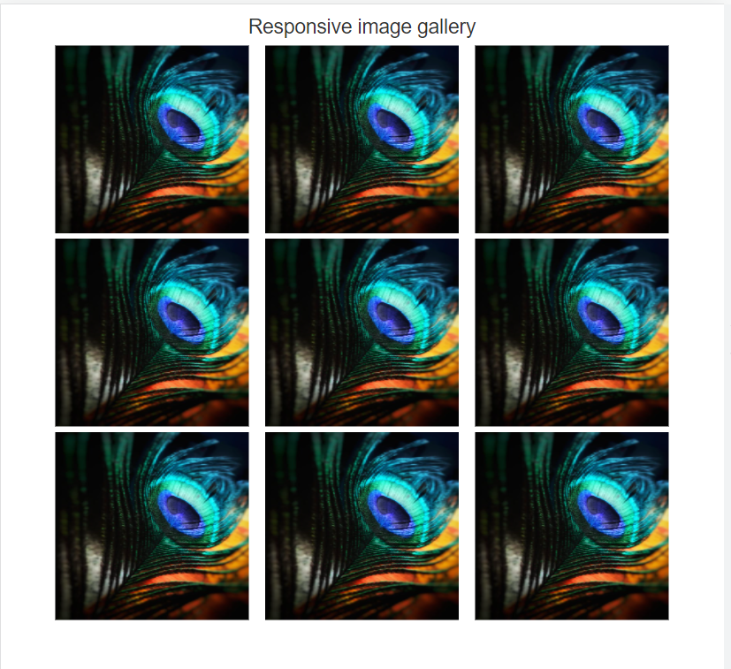

***10.Create an HTTP server using Node.js which handles requests on port 10000 or a free port beyond 10000. Modify the server in such a way that opening the localhost at 1000 should display Hello World,”This is my Node js.server” on browser.***

var http=require('http');

http.createServer((request,response)=>{

response.write('hello world,this is server 1');

response.end();

})

.listen(10000,()=>console.log('Server started at the port number 10000'));

***OUTPUT***



